

INTRODUCTION:

Estimating business expenses involves a structured process to project and plan for costs associated with operating a business.

# Overview:

Categorize expenses: Identify and categorize all potential expenses your business may incur. Common categorize include personal, rent, utilities, marketing, supplies, and more.

Fixed vs. variable expenses: Distinguish between fixed expenses (e.g. , rent) that remain constant and variable expenses (e.g. ,utilities) that fluctuate.

Historical data: Review historical financial records if available to identity patterns and trends in past expenses.

Market Research: Research industry benchmarks and standards to gauge typical expenses for businesses in your sector.

Creating a Budget : Develop a detailed budget that outlines projected expenses for the upcoming period (monthly, quarterly, annually)

Operation costs: Include expenses related to day-to-day operations, such as office supplies, maintenance, and travel.

Marketing and Advertising : Budget for marketing campaigns, advertising, and promotional expenses.

Taxes and legal fees: Estimate taxes and any legal fees or permits required for your business.

# PURPOSE:

Resource Allocation: It helps in allocating resources, such as capital, labour, and materials, to meet the business’s operational needs.

Cost control: Estimation enable businesses to set cost-control measures to ensure that expenses remain within the budgeted limits.

Decision-making: It assists in making informed decision about investments, expansion, and pricing strategies by understanding the cost implications.

Tax planning: accurate expenses estimates assists in tax planning, advantage of applicable deductions and credits.

Budgeting and financial planning: It allows businesses to create a structured financial plan that outlines expected expenses, helping to allocate resources effectively.

Profitability Analysis: Estimating expenses helps evaluate the potential helps evaluate the potential profitability of a business by comparing projected expenses to expected revenue.

PROBLEM DEFINITION & DESIGN THINKING:

## EMPATHY MAP

IDEATION & BRAINSTORMING MAP

## 

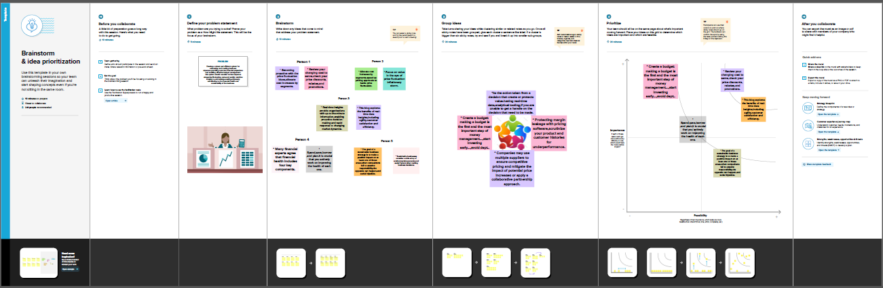

# RESULT:

## CREATING DASHBOARD, STORY USING TABLEAU AND ANALYZING ESTIMATION OF BUSINESS EXPENSES

# ANALYSIS OF ESTIMATION OF BUSINESS EXPENSE

# Break down: insights into diverse business costs

# 

# Expenditure overview

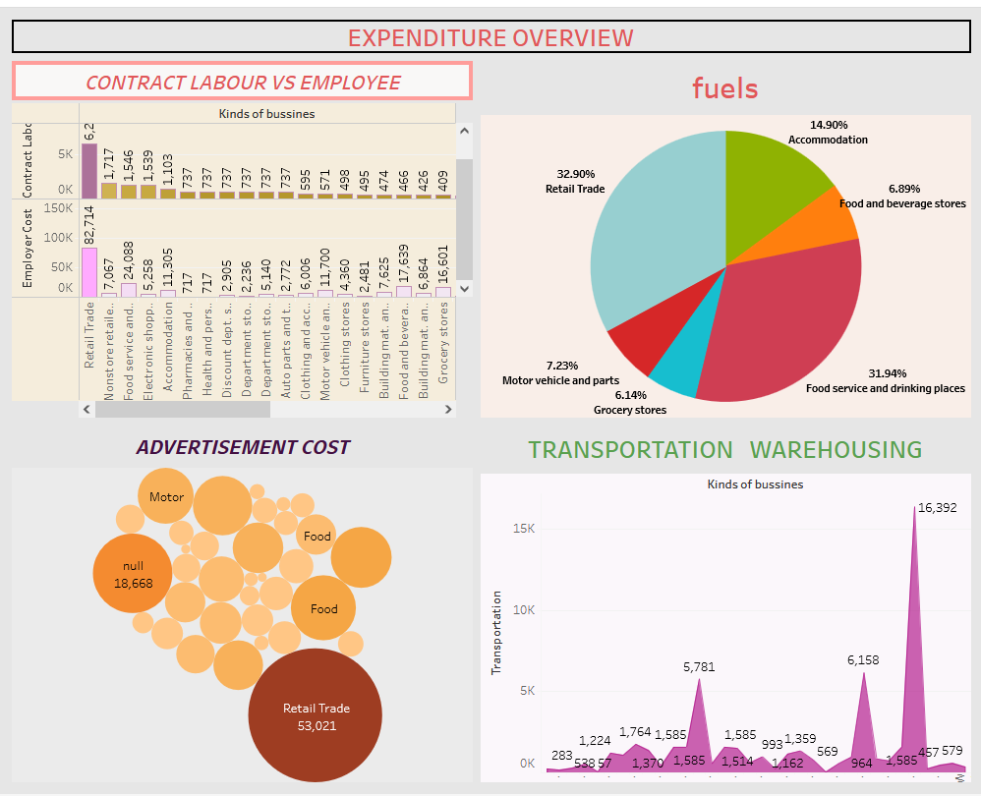

# Expenses insights

# 

# Expenses 1

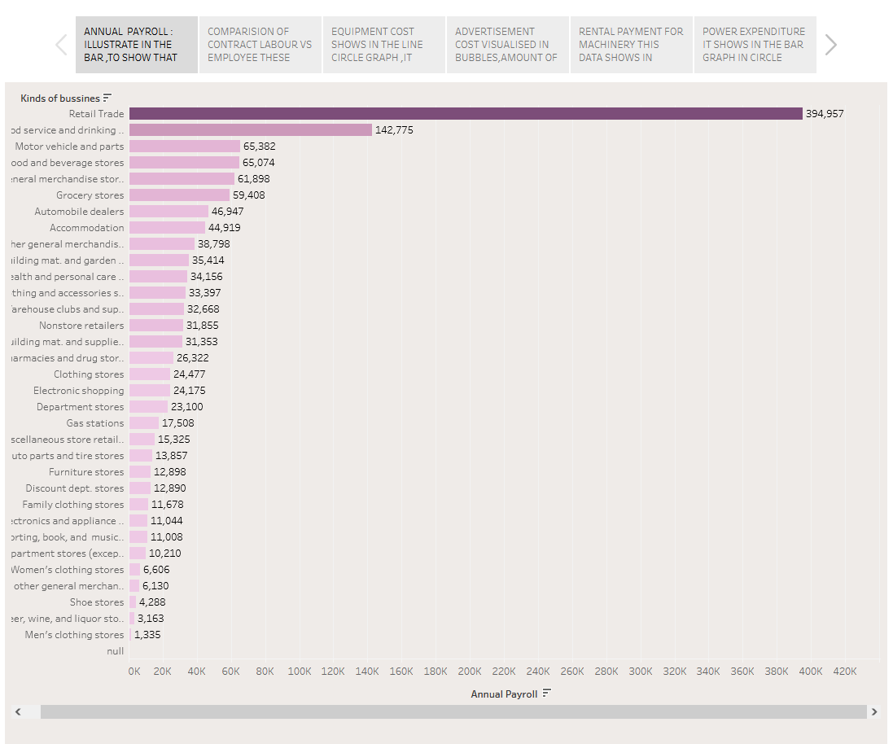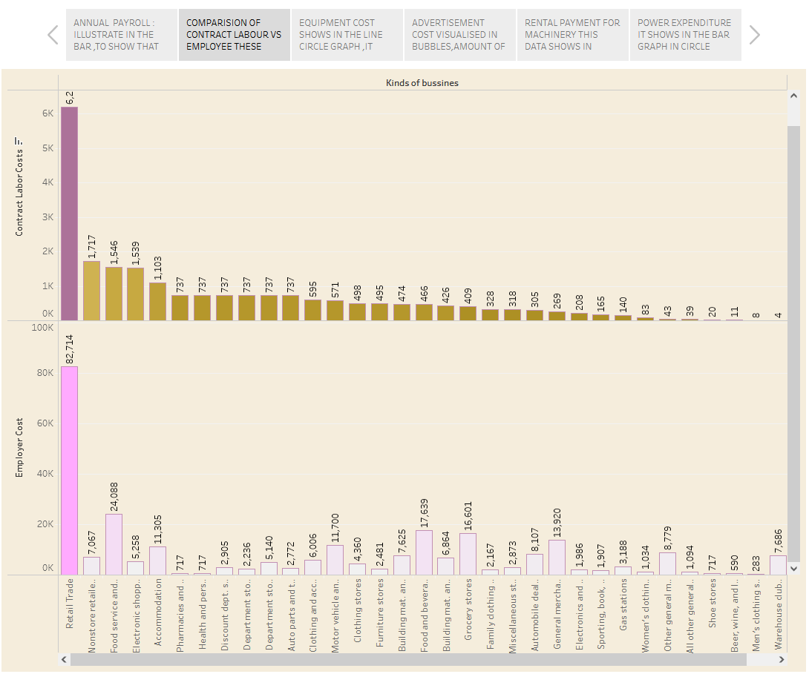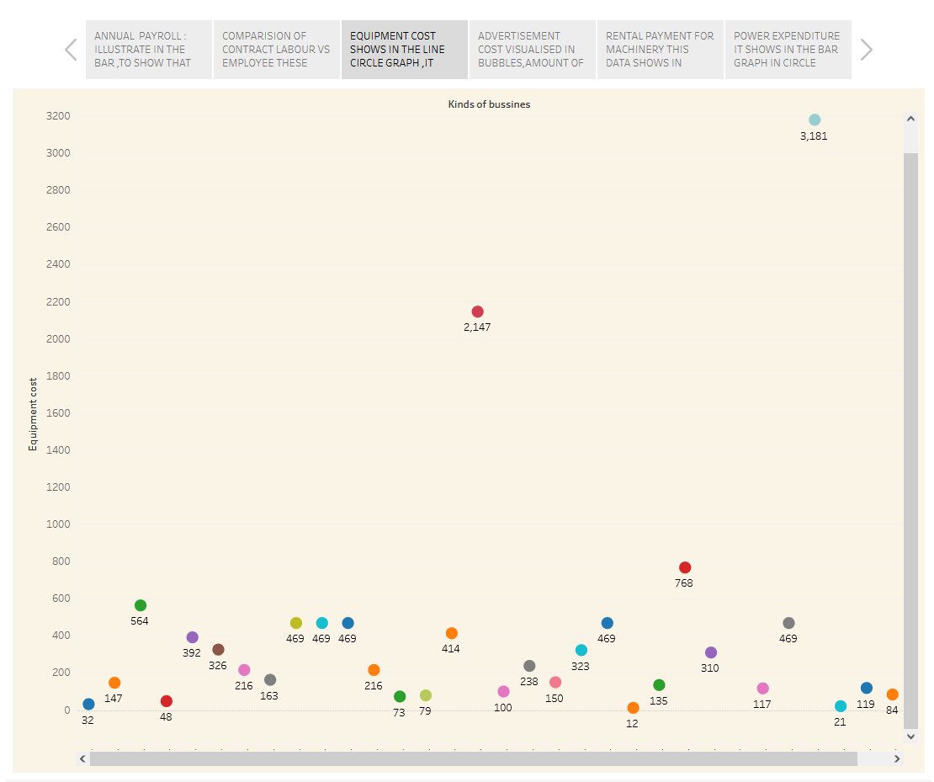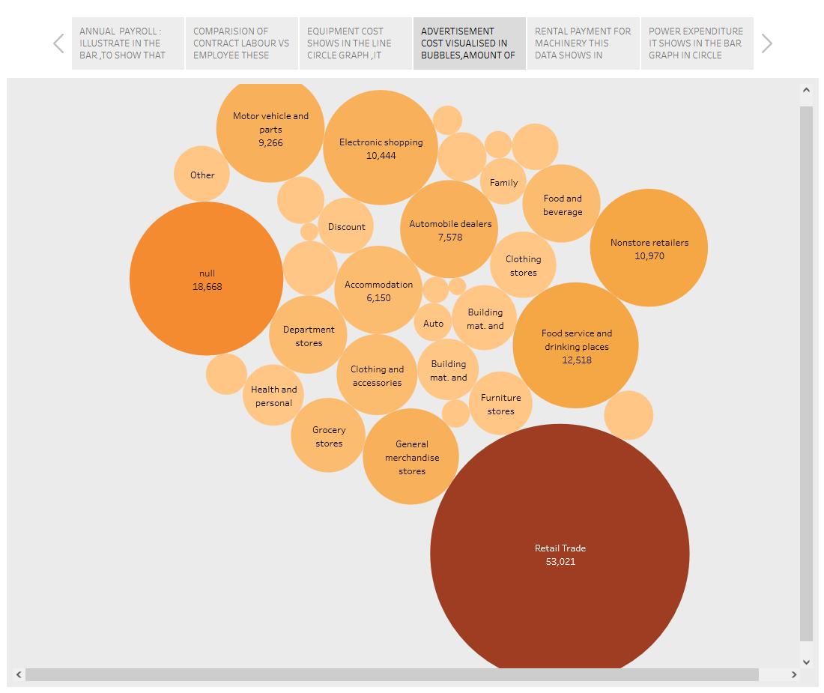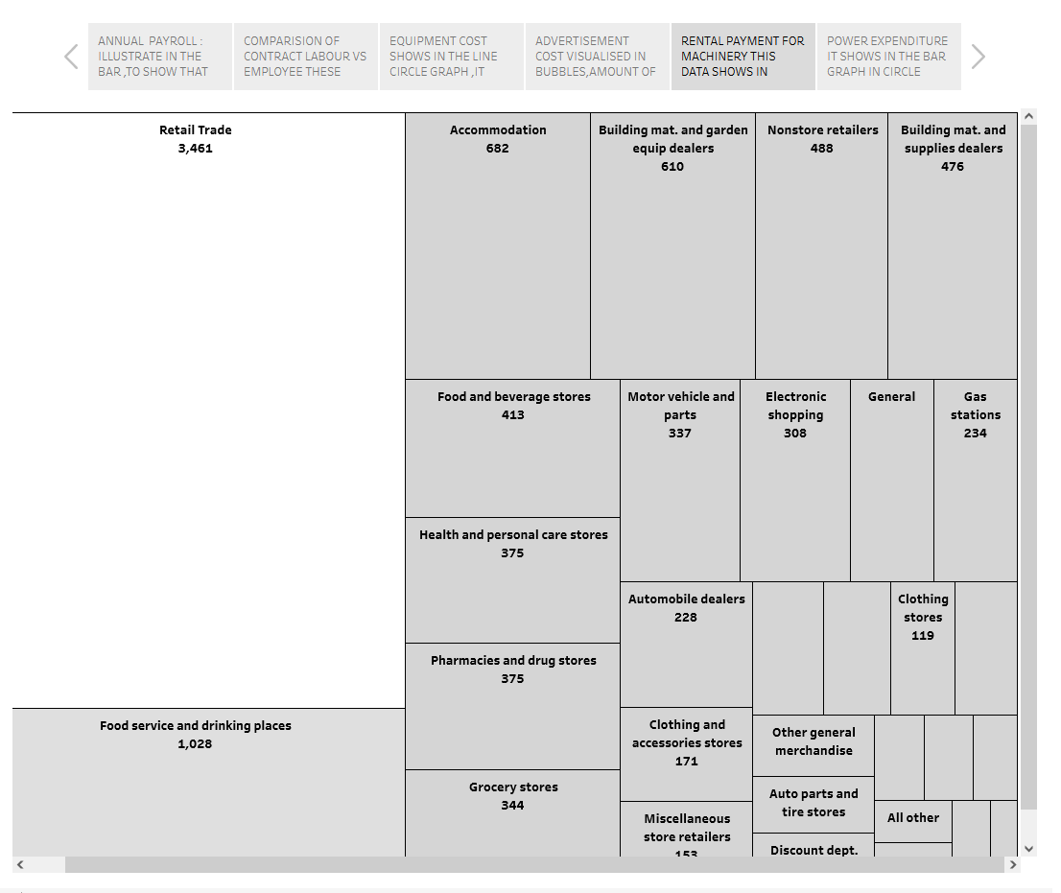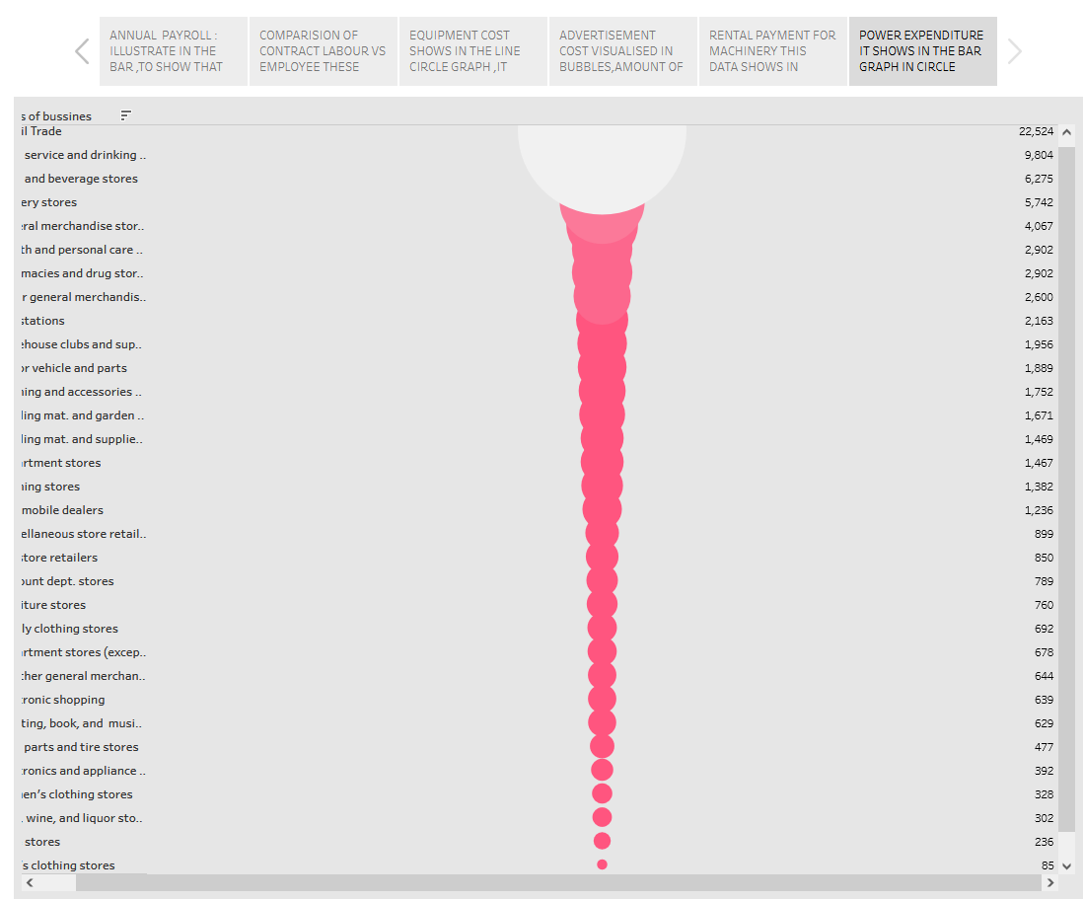

# Expenses 2

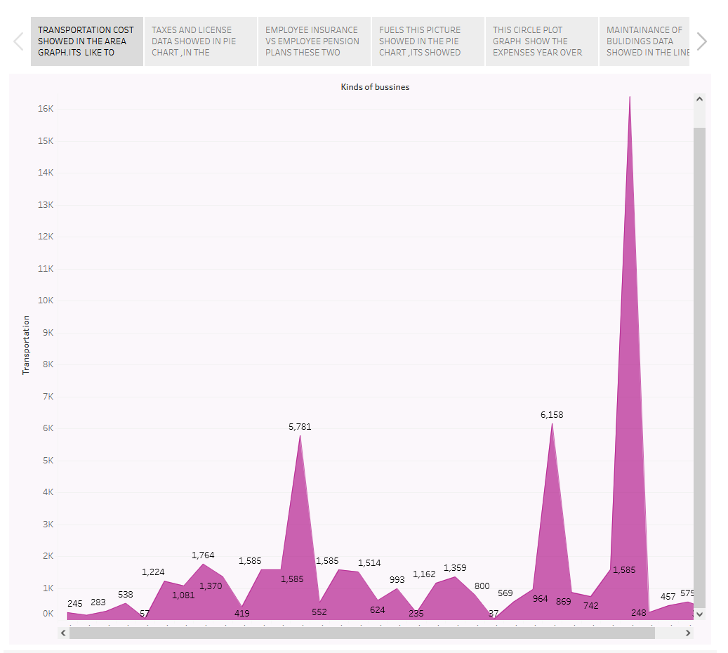

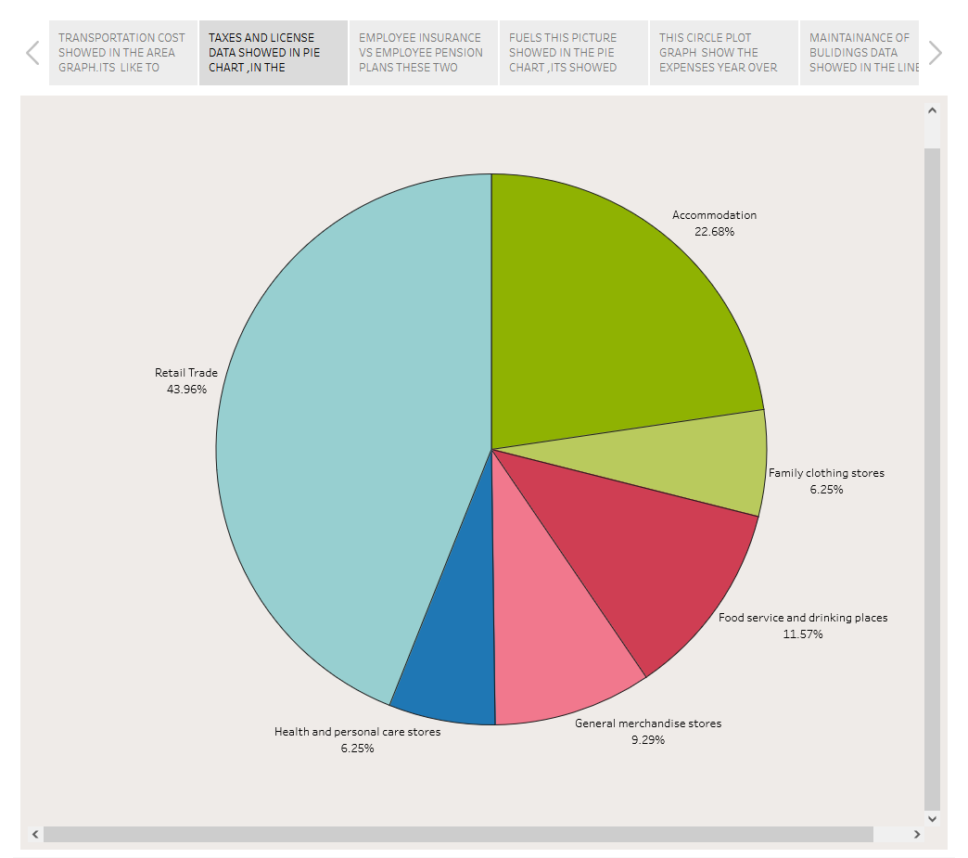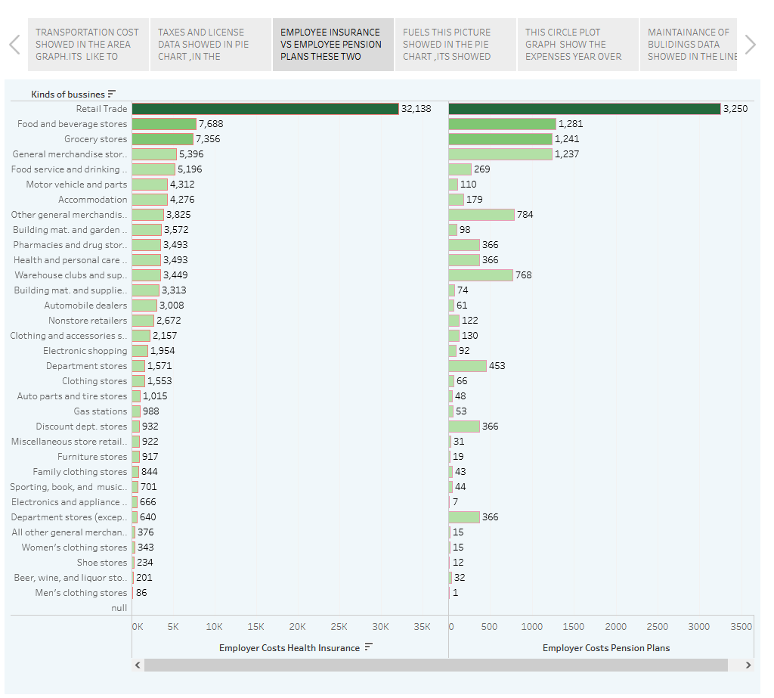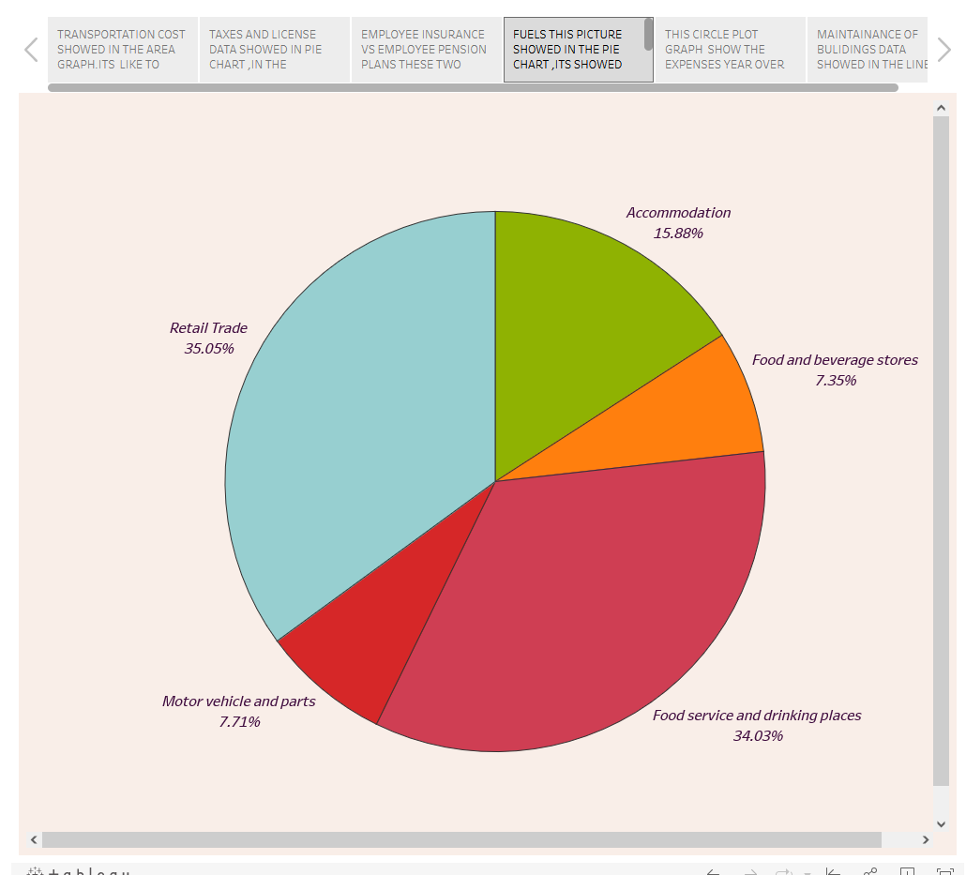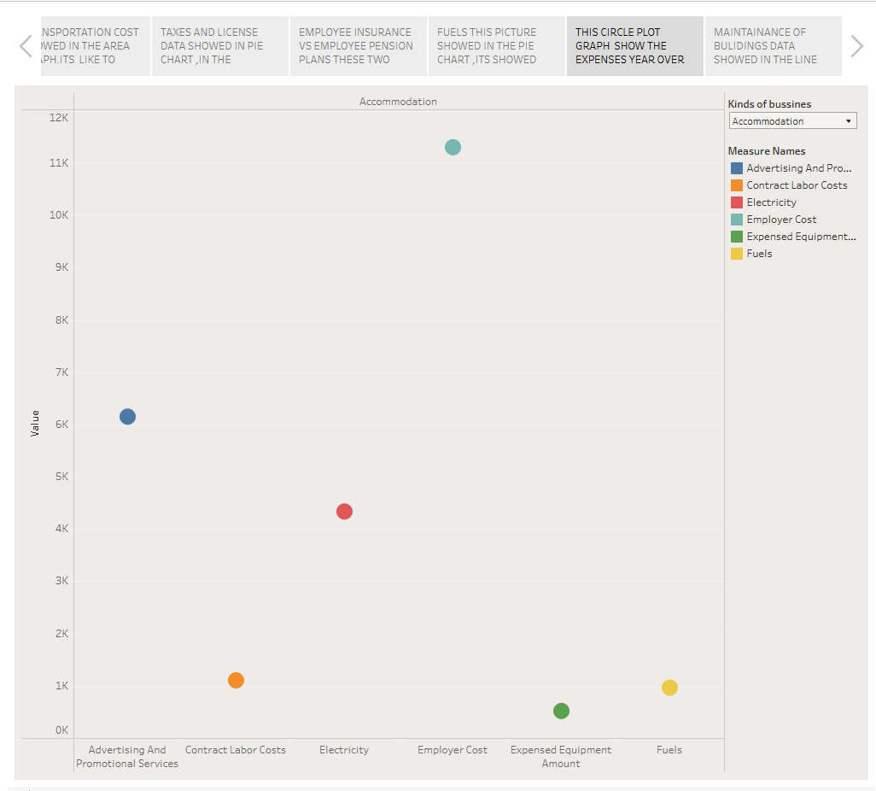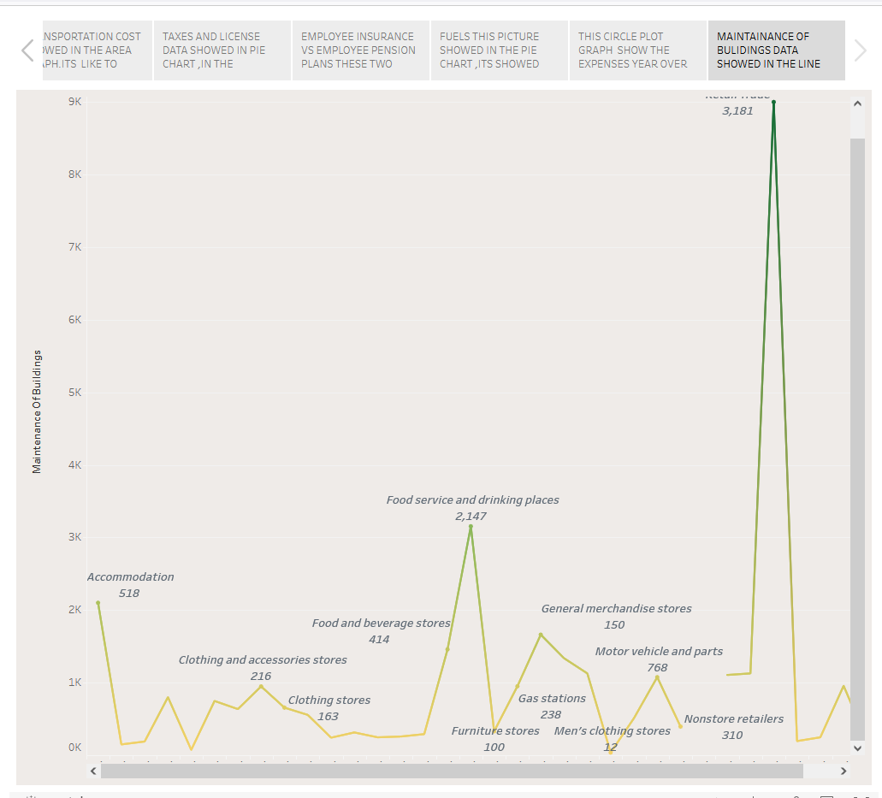

# ADVANTAGES

### THE EMPATHY MAP TEMPLATE HELPS YOU:

* An empathy map is a template that organizes a user’s behaviors and feelings to create a sense of empathy between the user and your team
* The empathy map represents a principal user and helps teams understand their motivations, concerns, and experience.

### THE BRAINSTORMING & IDEATION PRIORITIZATION TEMPLATE HELPS YOU:

* Problem Solving: they are a powerful tool for problem-solving and decision-making, helping to explore different solutions and their implications.
* Organization: Brainstorming maps enable you to organize and structure your thoughts

### DASHBOARD IN TABLEAU:

* Data Visualization: Dashboard allow you to create visually appealing charts, graphs, and maps to represent your data, making it easier to understand complex datasets
* Interactive : users can interact with the data on the dashboard, such as filtering, drilling down, or hovering over data points to get more information, enhancing data exploration

## STORY IN TABLEAU:

* Data comparison: you can include multiple dashboards or sheets in story, making it easy to compare data across different views and time periods
* Storytelling for impacts: Stories are an effective way to communicate insights and findings to non-technical stakeholders. They can make data more engaging and memorable, leading to more informed decisions.

# DISADVANTAGES:

### DISADVANTAGES OF EMPATHY MAP:

* They are designed to capture the needs and perspectives of a specific audience, but may not capture the needs and perspectives of other stakeholders

### DISADVANTAGES OF BRAINSTROMING:

* Group think: In a group setting, there’s a risk of groupthink, where participants conform to the dominant ideas or opinions rather than expressing their unique thoughts.

## DISADVANTAGES OF DASHBOARD IN TABLEAU:

* Data Connectivity: Connecting to certain data source may be challenging, especially if they are not well-supported or require custom configurations.

## DISADVANTAGES OF STORY :

* Less Control Over Layout: Stories have a predefined layout structure, and customization options are more limited compared to creating custom dashboards.

# APPLICATIONS:

#### EMPATHY MAP

* User-Centered Design: Empathy maps help design teams understand the needs, emotions, and behaviors of users, guiding the development of products or services that better meet their requirements.

#### BRAINSTORMING :

* Problem –Solving : Brainstorming is an effective tool for identifying solutions to complex problems, whether in business or any other field.

#### TABLEAU:

* Business Intelligence : Tableau is widely used for business intelligence purpose, allowing companies to analyze and visualize data to make informed decisions. It helps in tracking KPIs, performance metrics, and generating reports.

## CONCLUSION:

* In Conclusion, the process of estimating business expenses is a fundamental element of financial planning for any organization. Accurate expense estimation allows companies to create realistic budgets, allocate resources effectively, and make informed financial decision. This project has highlighted the importance of considering historical data, market trends, and industry benchmarks when estimating expenses. Furthermore, it underscores the need for regular reviews and adjustments to these estimates to ensure financial stability and growth. Effective expense estimation not only helps in cost control but also in achieving long-term business objectives, making it a crucial component of successful financial management.

THE END….